Edge Intelligence Lab – 5

Training and Fine Tuning a classifier for Image Data

Open Edge Impulse and Login into Edge Impulse

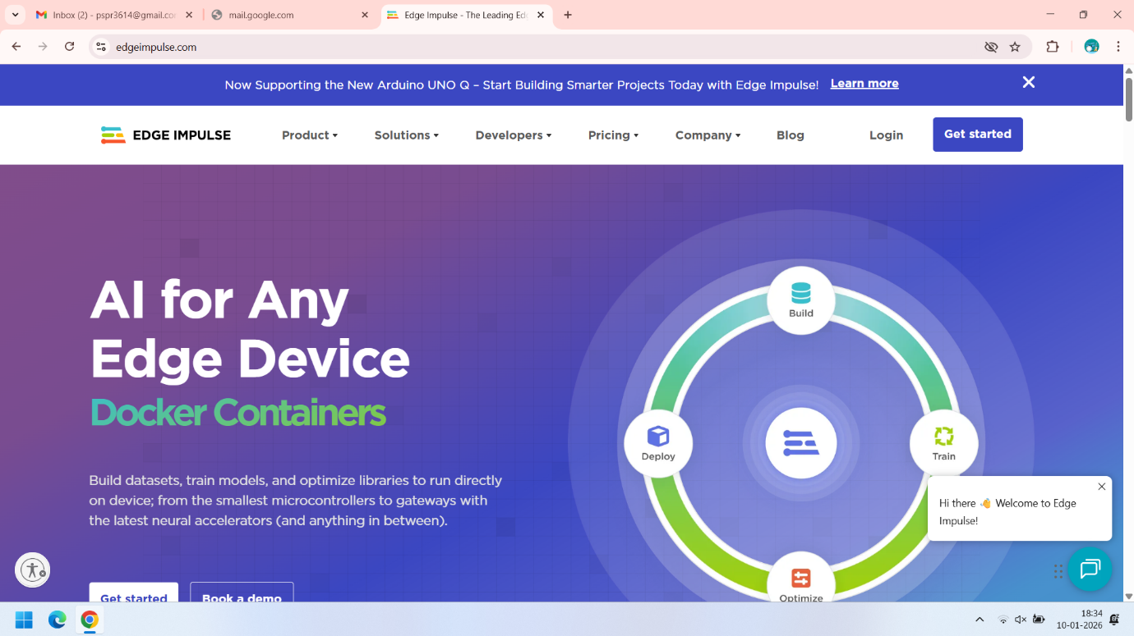

After logging into the Edge Impulse we can See the Dashboard. Now we have to select the Project that we are working. Here the Sasi_Preetham_Reddy-project-1 is the project that we have used previously for Data Acquisition . Now we have to click on that.

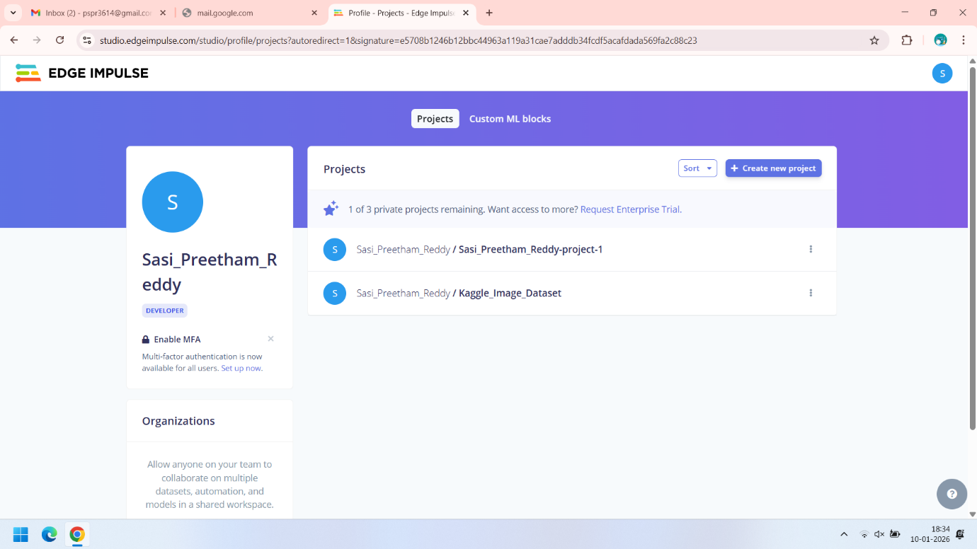

Once we click on that and we open Data Acqusition we can see that images that we have previously collected.

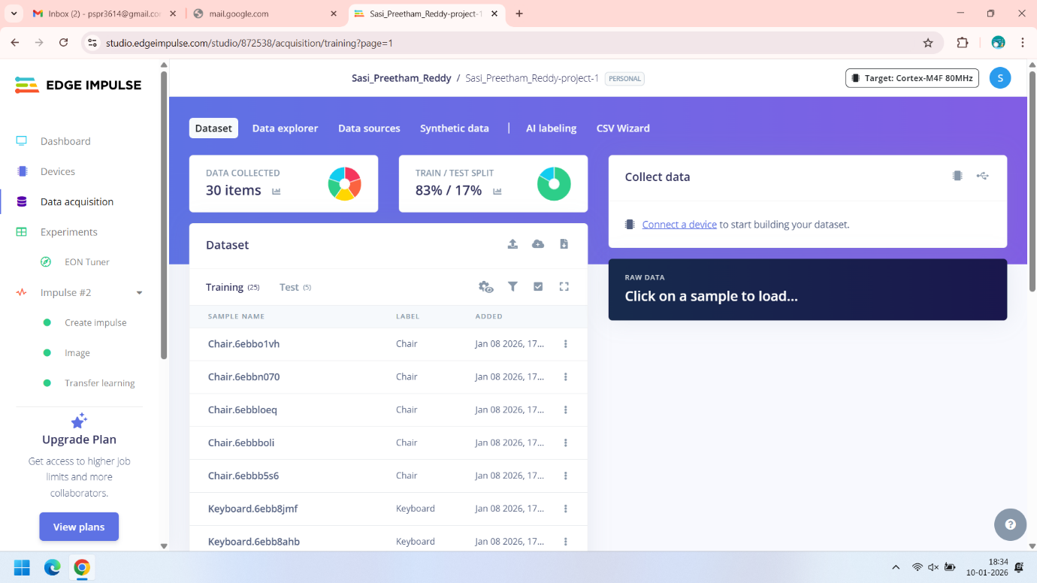

So we can see here we have collected a total of 30 images , where 83% of the data is used for training and 17% data is used for testing

Now to train the classifier we will click in the create impulse.   
  
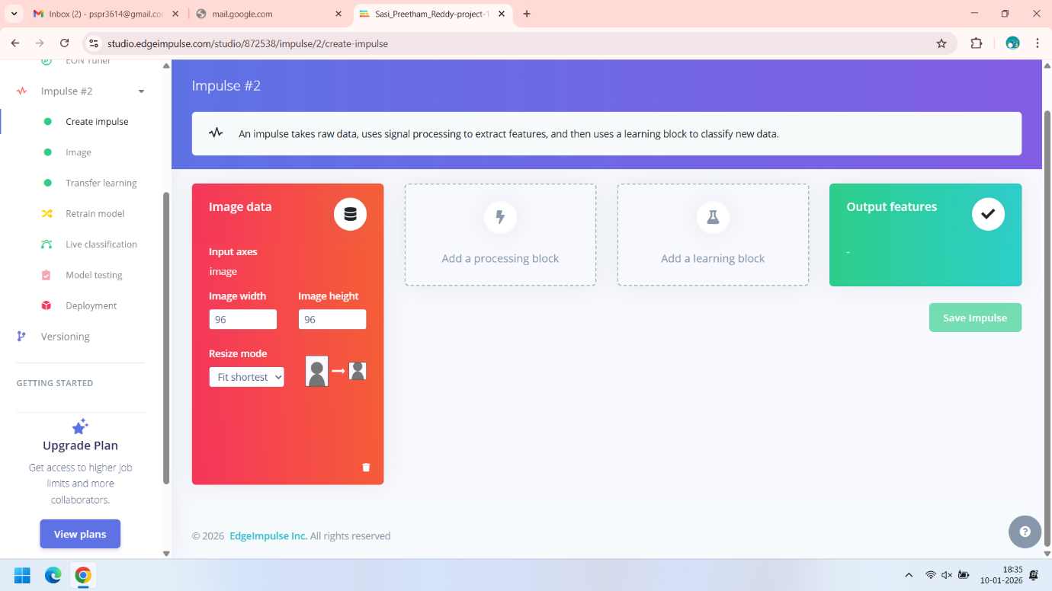  
  
Here we can see that ou input is an image data with image height and width as 96. Now here we have to add the processor block and the learning Block. In order to create the processor block we will click on the add processor block.

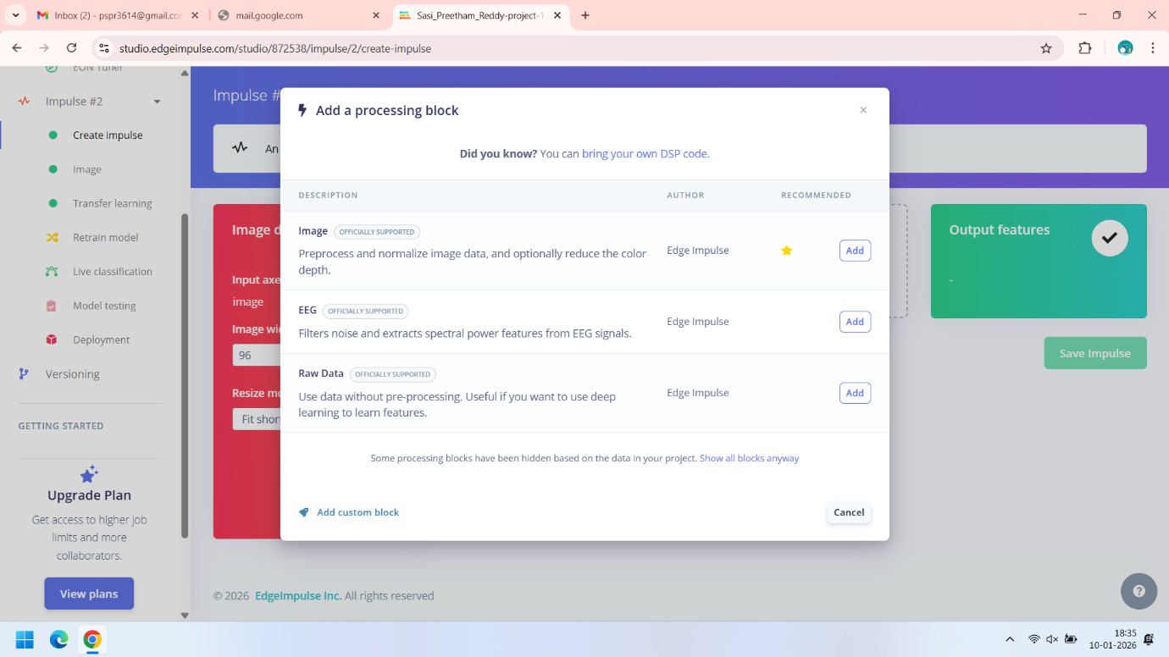  
  
Here we have multiple processor blocks, As we are dealing with the images we will click on the add button that is in front of the image  
  
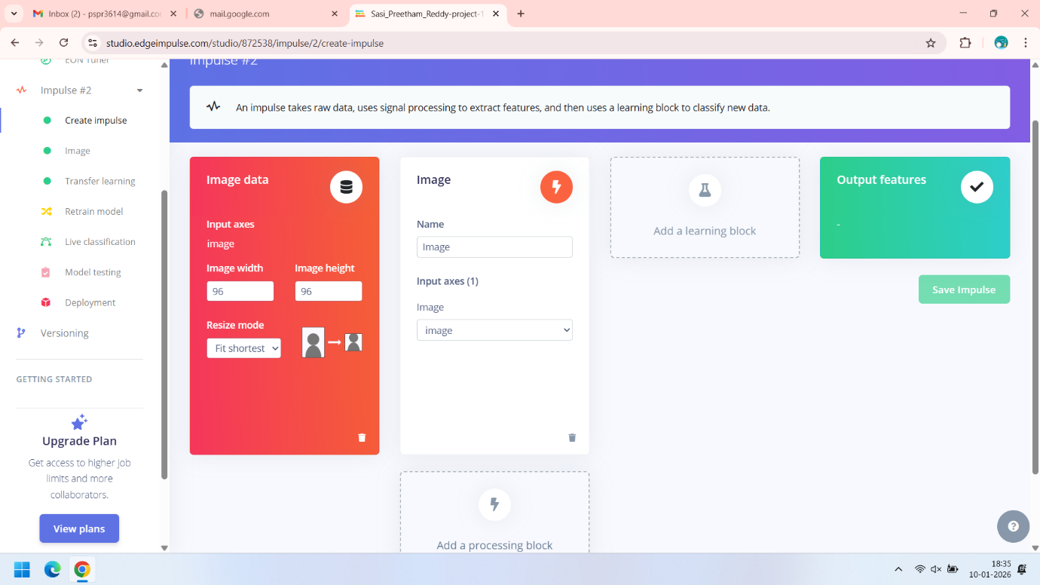   
  
Now we have successfully added the image block .Now we need to add the Learning block . Here we are trying two Types of learning blocks one is classifier and other is transfer learning.

1. Using the Classifier Block

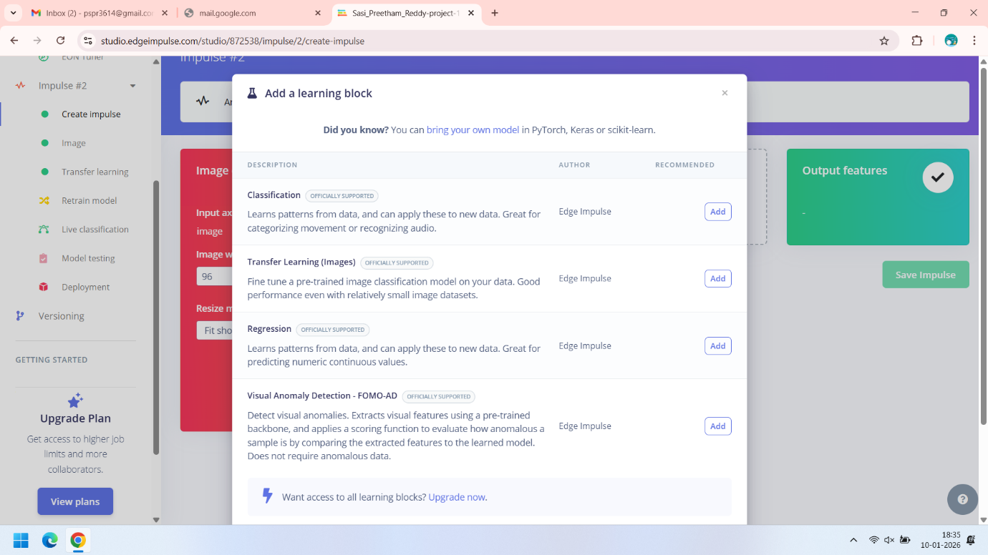  
  
Once you click on the add Learning block you will get a pop up. Here in order to get the classifier we need to click add in front of the classification.  
  
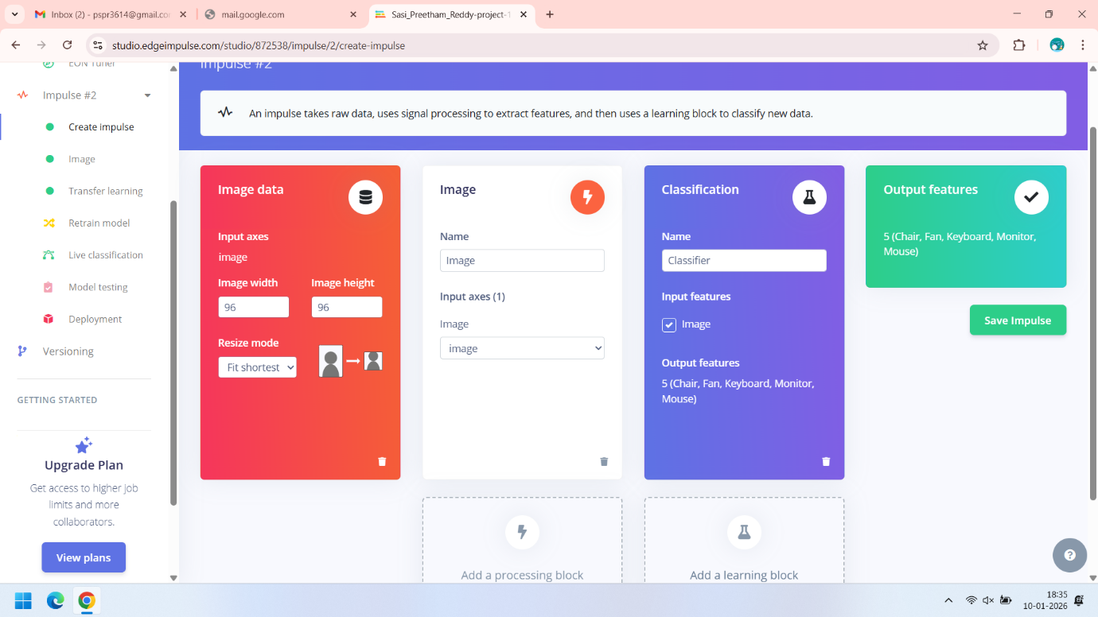  
  
Now we have successfully added Both processor block and Learning block. Here we can also see the output features. There are total of 5 labels in our dataset. After that we will click on save impulse.  
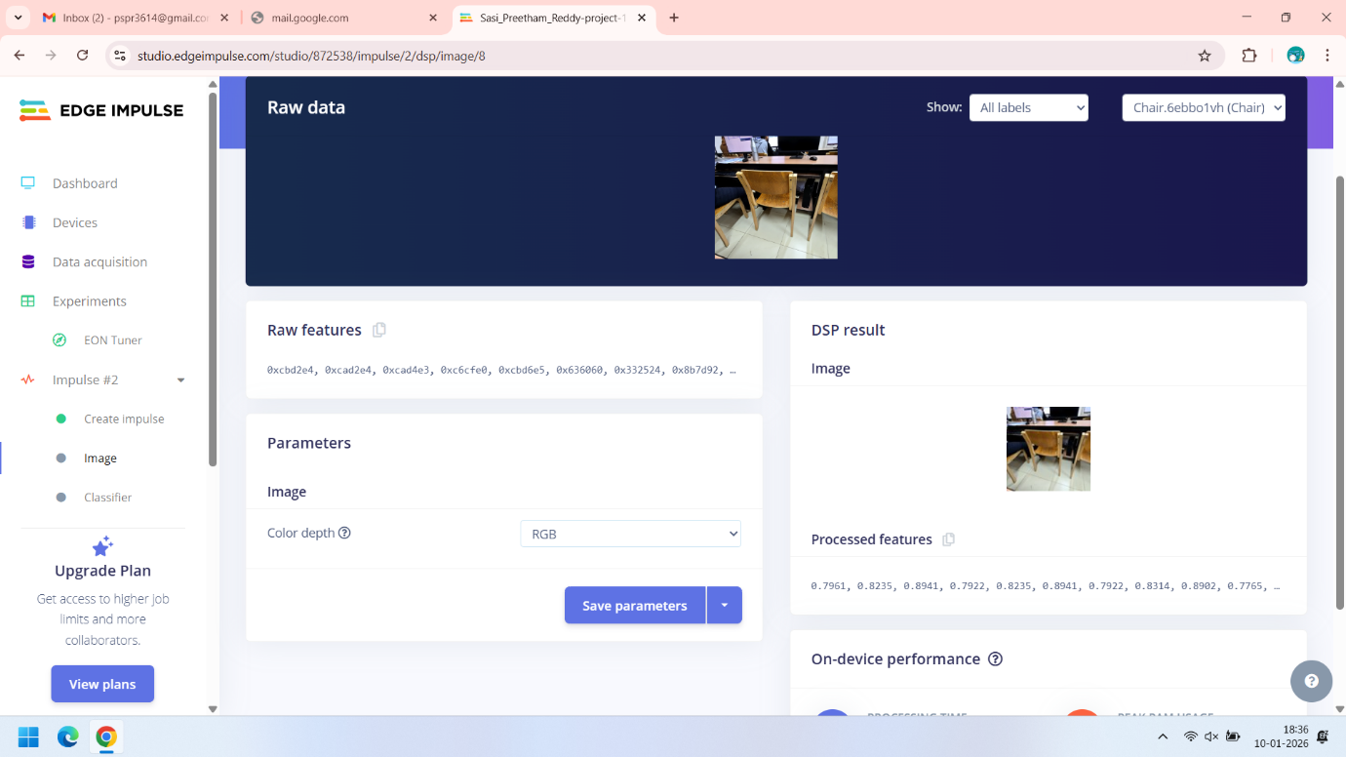  
  
Now we click in the image on the left pane. Here for color depth there are two options one is Color images i.e. RGB and we have greyscale. For this project we are using grey scale.   
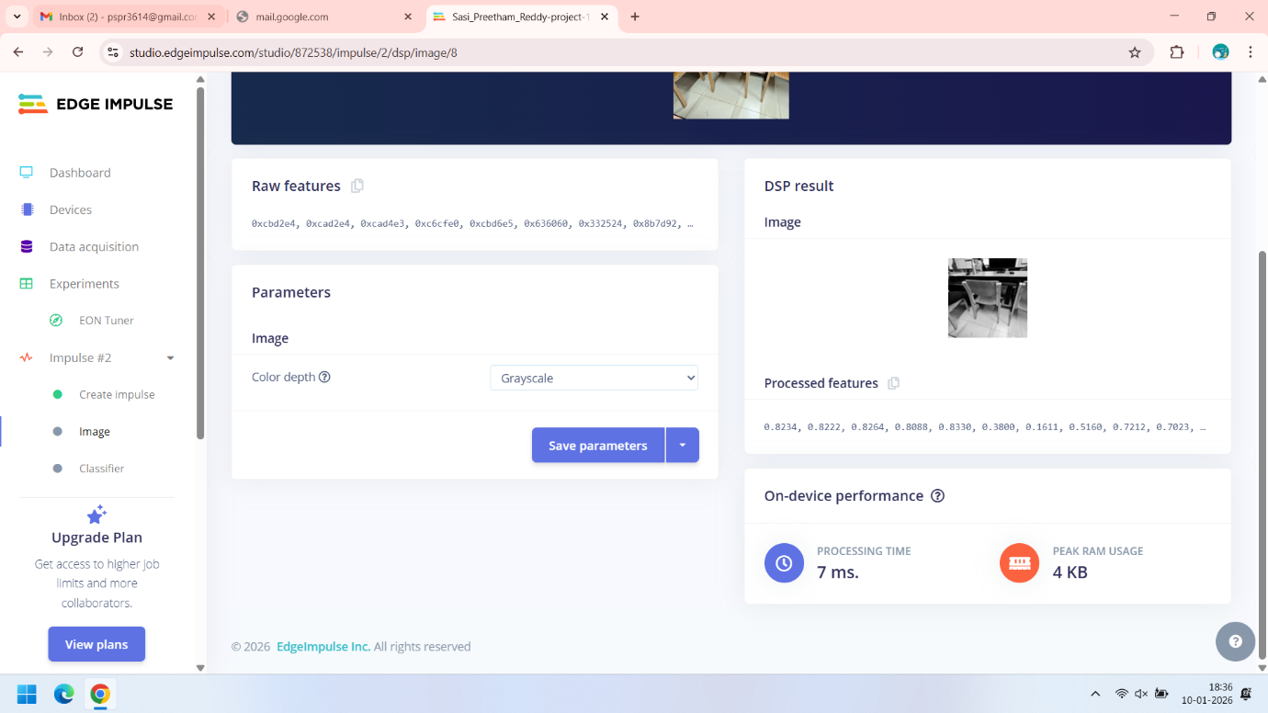  
  
Here we can see that we have changed the color depth to greyscale. On right side we can see the image of the chair in greyscale and the processed features of the chair image .  
  
Now click on save parameters.

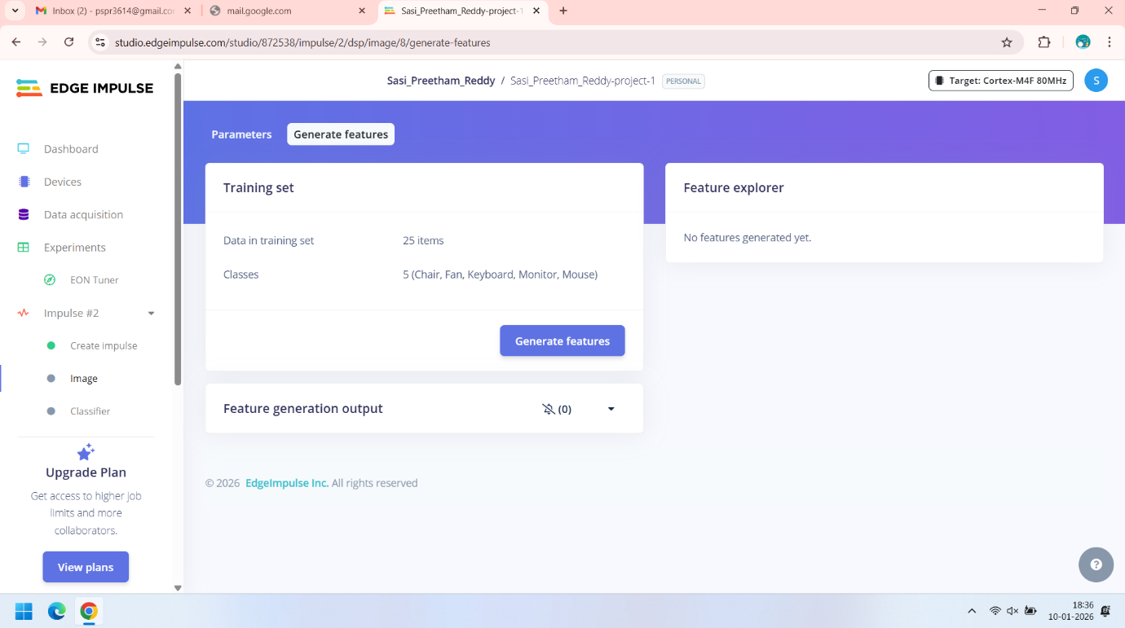  
  
After saving the parameters we will click on the generate features and we will the output as show below.

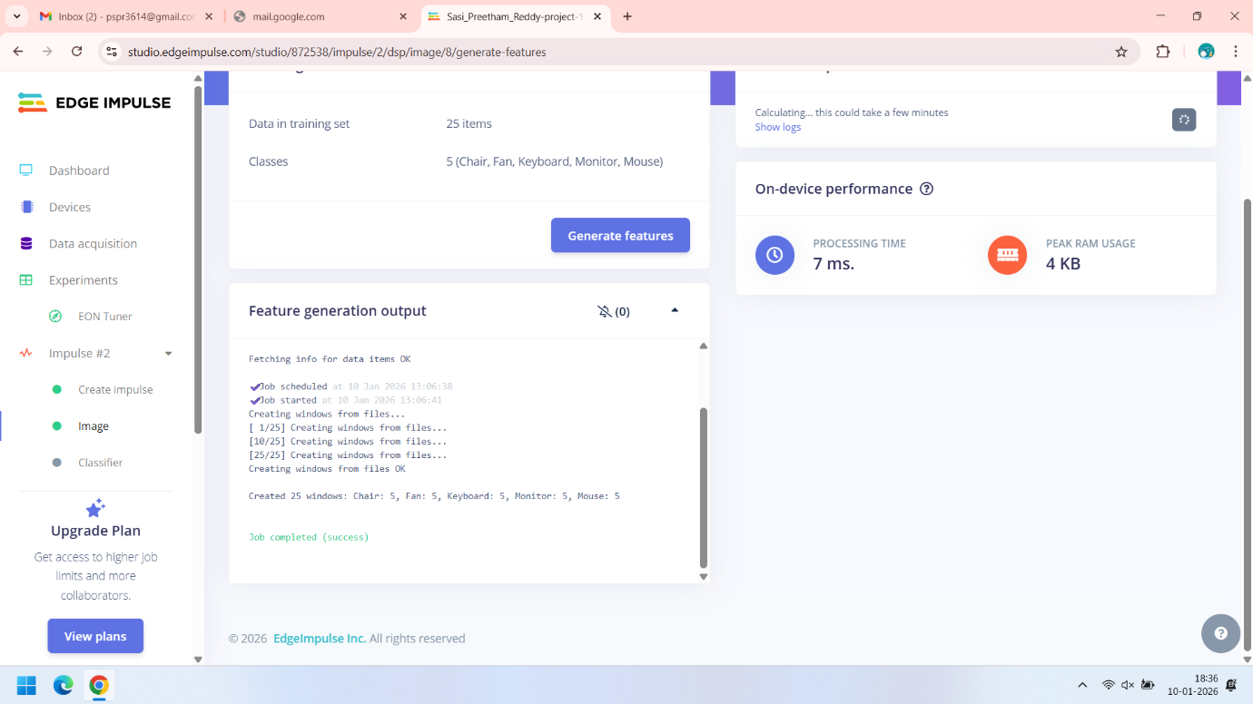  
  
After Generating the features we can now move to build the classifier.  
click on the classifier in the left side panel .

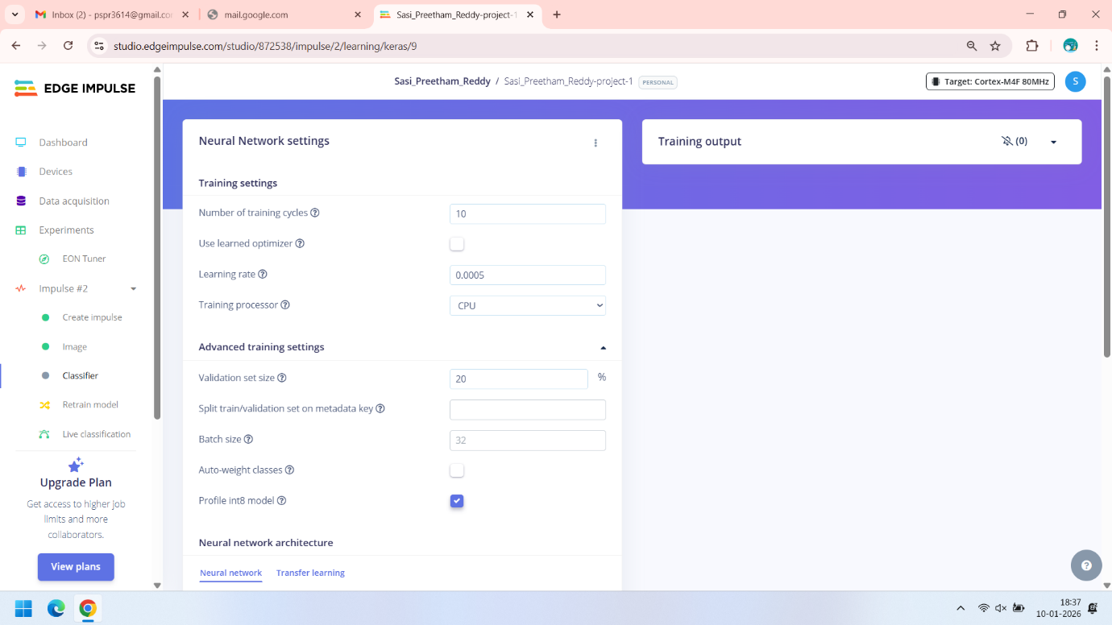  
  
Here we can see the neural network settings . here set up our settings like number of training cycles, learning rate, training processor , validation set size , batch size etc.. Here i am using 10 training cycles and 0.0005 learning rate . I am using CPU to train the model we can also use GPU   
  
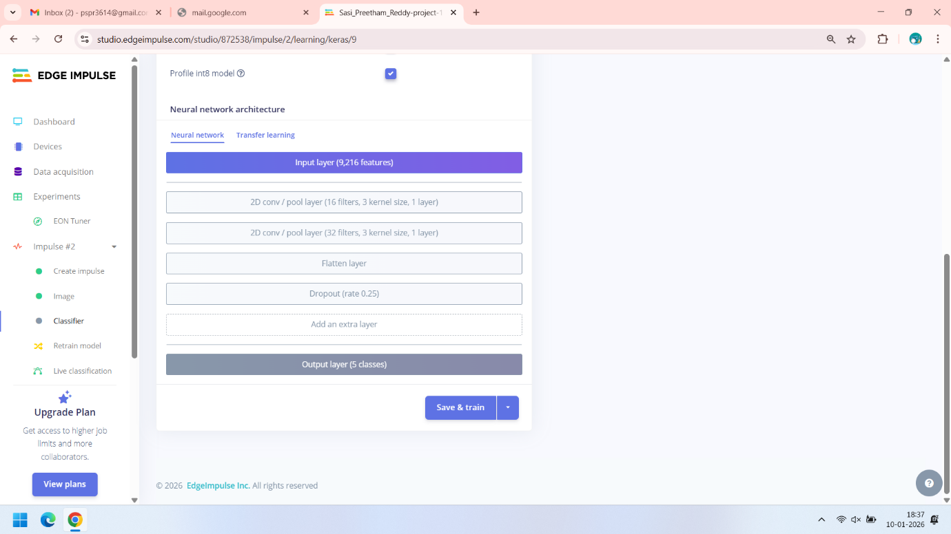  
  
This is the initial architecture that will be given by default. It contains 2 Convolution layers followed by a flatten and dropout layer . Here we can also add our extra layers.   
  
Lets add an Dense Layer by clicking on the add extra layer

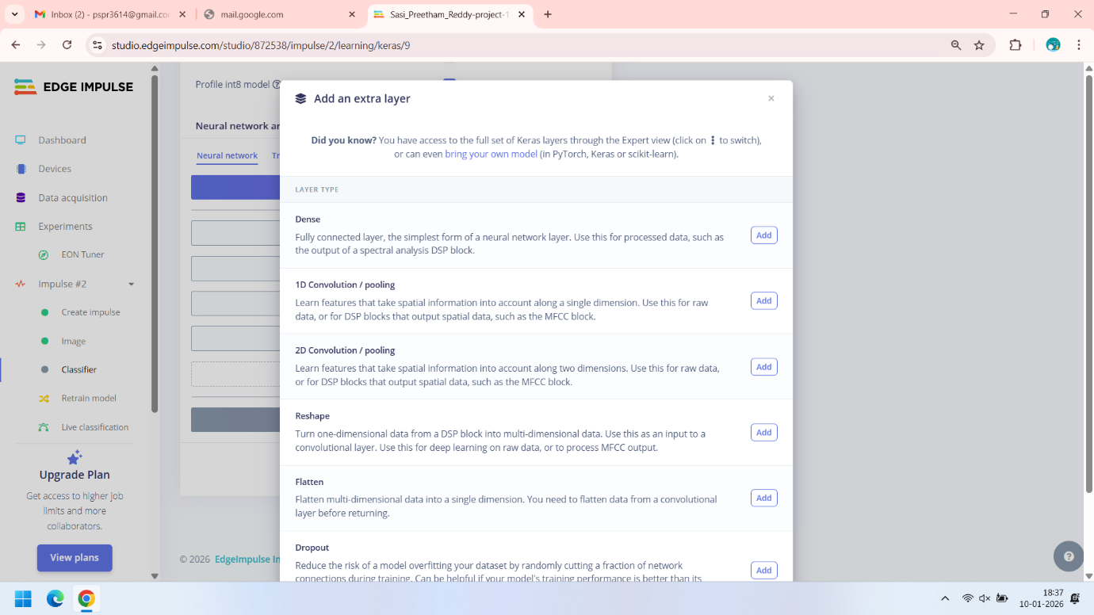  
  
Here we select Dense Layer with 64 neurons  
  
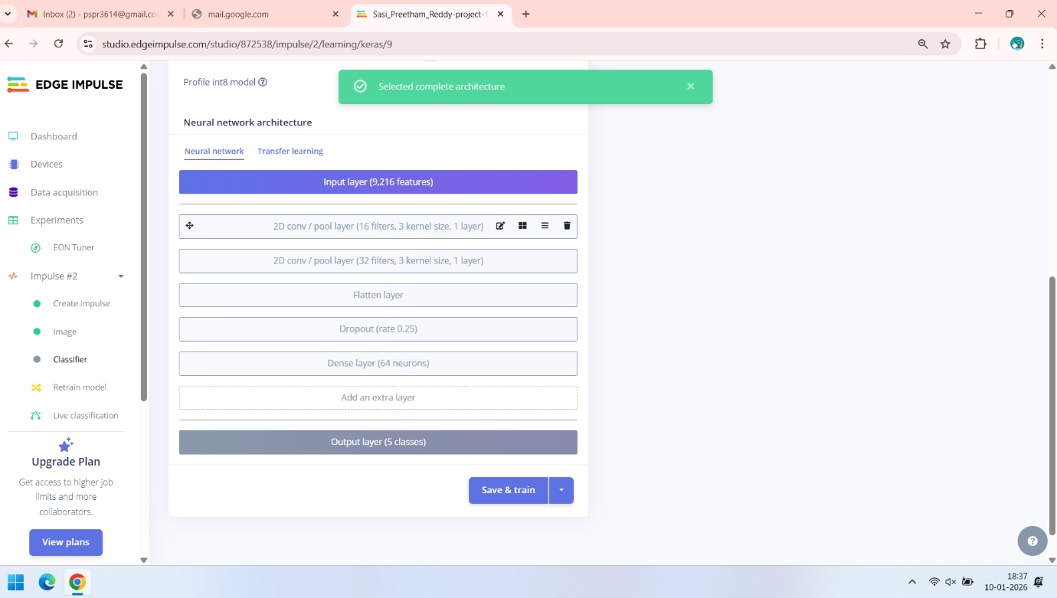  
  
Now I simply click on save and train . this saves the model and starts training of my model / classifier . we can see the output of the model training in the top right window.   
  
Below are the some of the screen shots while the model is training .  
  
  
  
  
  
  
  
  
Training screenshot -1   
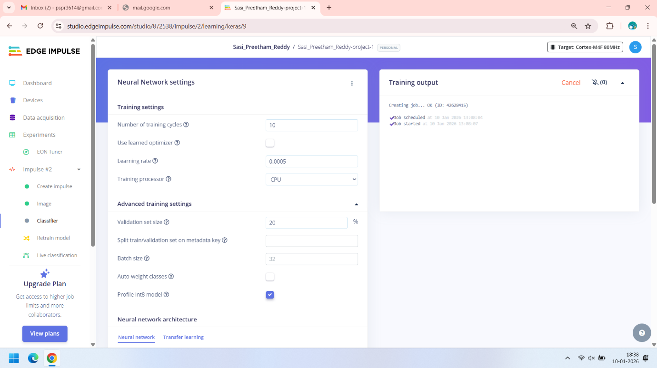  
  
  
  
Training screenshot -2  
  
  
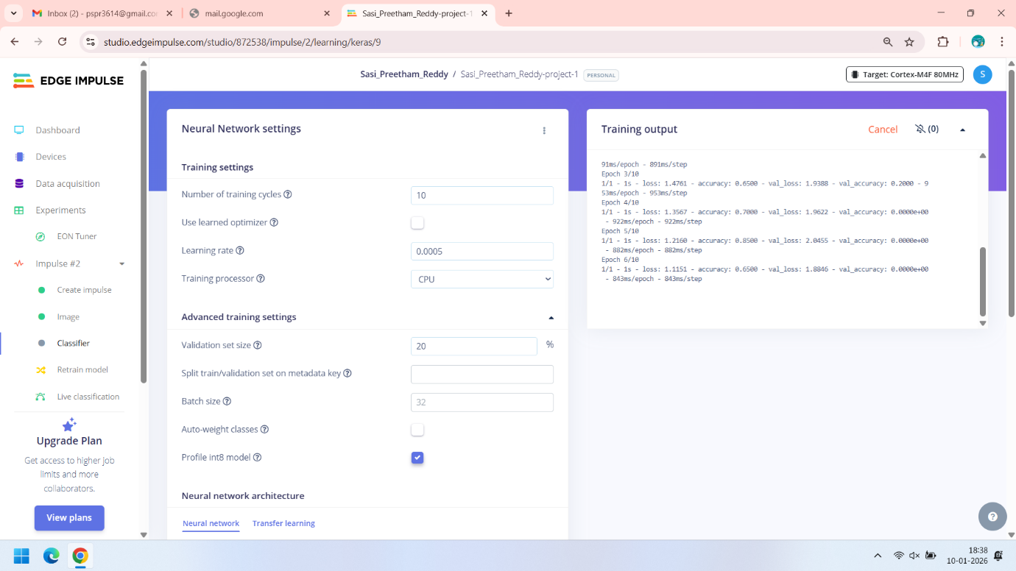   
  
  
  
  
  
  
  
  
Training screenshot -3  
  
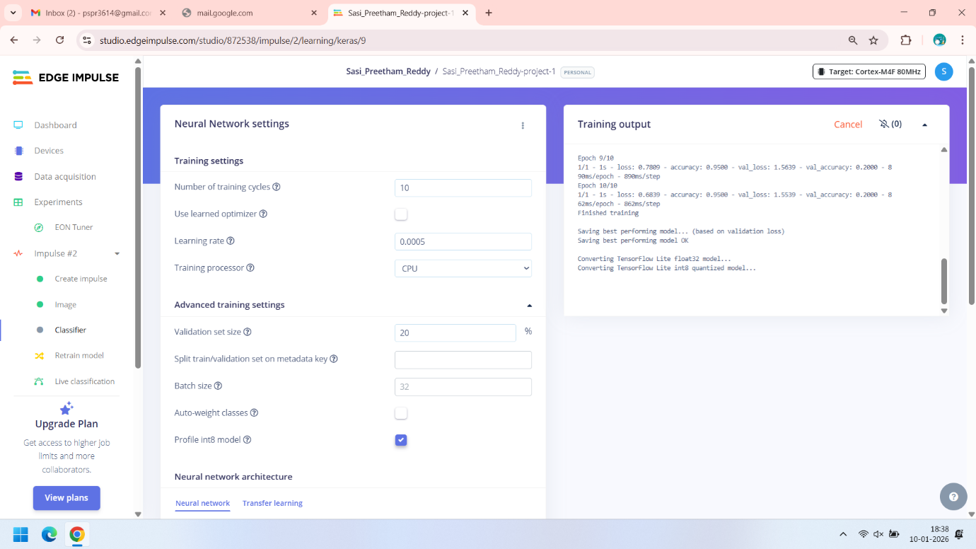  
  
  
Training screenshot -4  
  
  
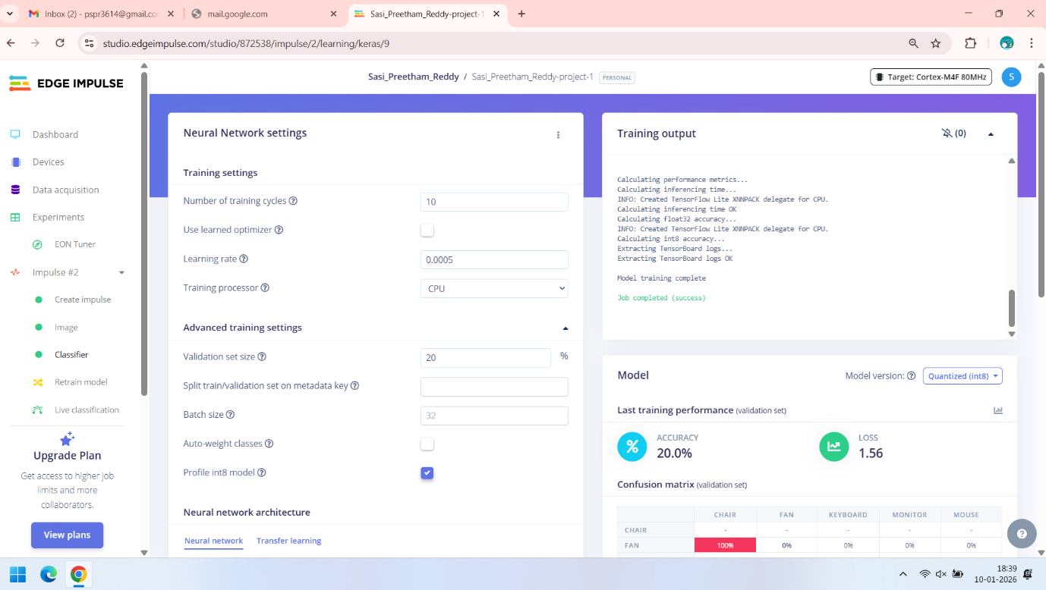   
  
  
  
  
  
  
  
  
  
  
Training screenshot -5   
  
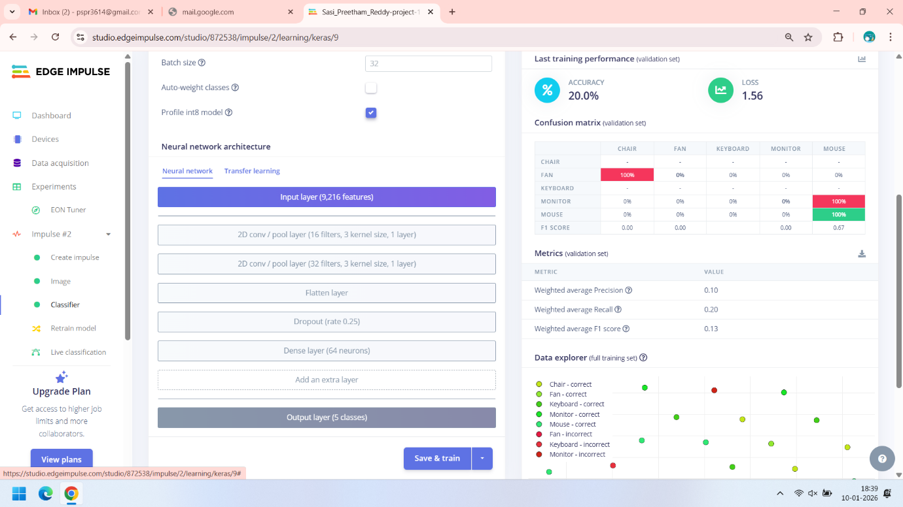  
  
Here we can see the training accuracy we got is just 20% with loss of 1.56. we can modify the architecture and we can retrain the model to get better accuracy.  
  
We can classify the new sample using the Live Classification. We can do that by clicking on the Live classification on the left side of panel   
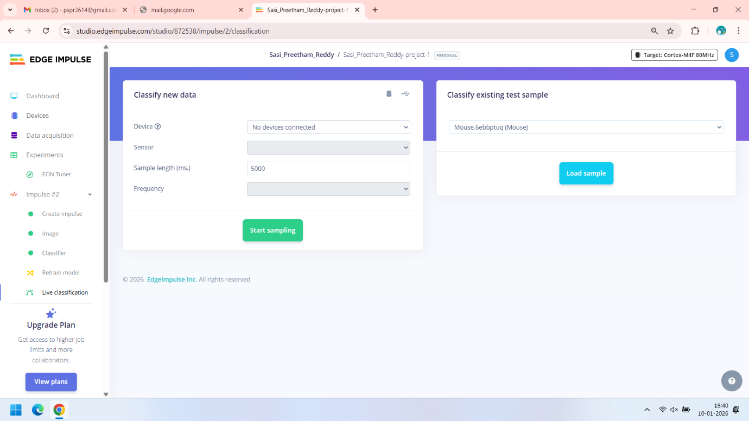   
  
We can predict the new samples by conneting to a board or we can load a sample from the existing sample . As we haven’t started working with boards we will load the image and we predict that sample . we will receive the following output  
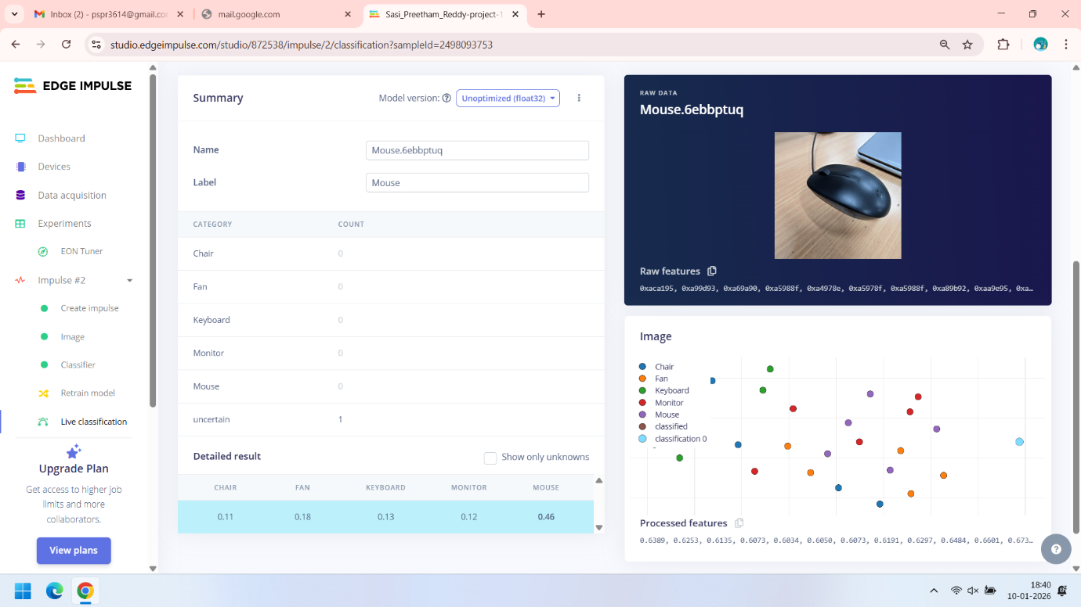  
  
Here we can see the probabilities of each label for the given sample image.   
  
We can deploy the model on edge device. We can do that by clicking on the Deployment tab. Here we may C++ library in order to deploy our model on the board.   
  
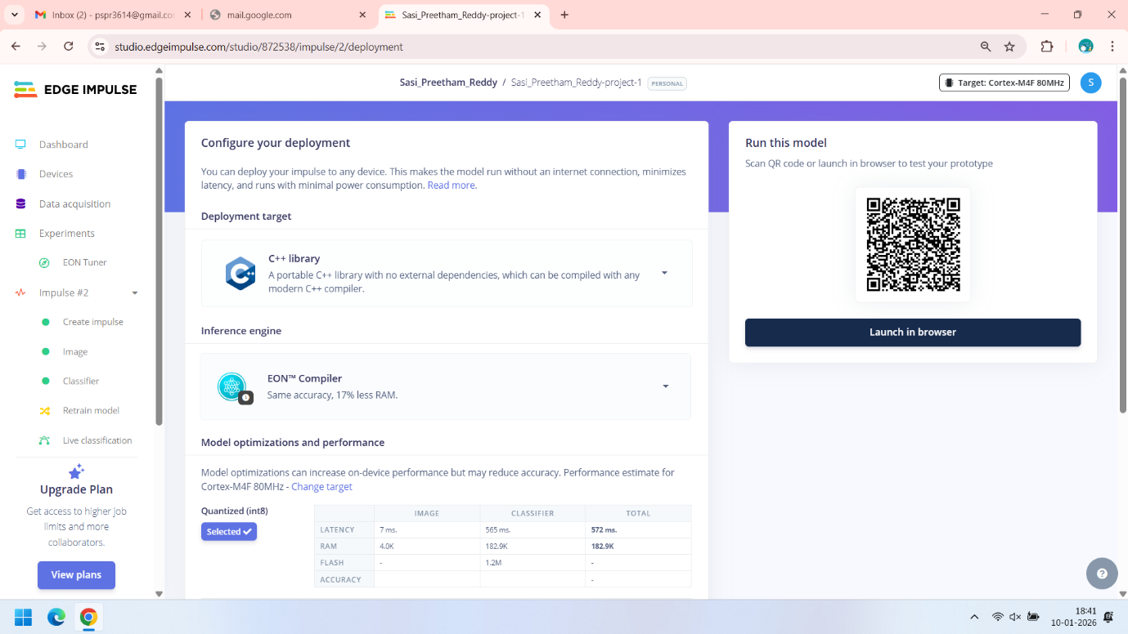

1. Transfer Learning

In order to do transfer learning as we already discussed we need to use the transformer block instead of classification block.  
  
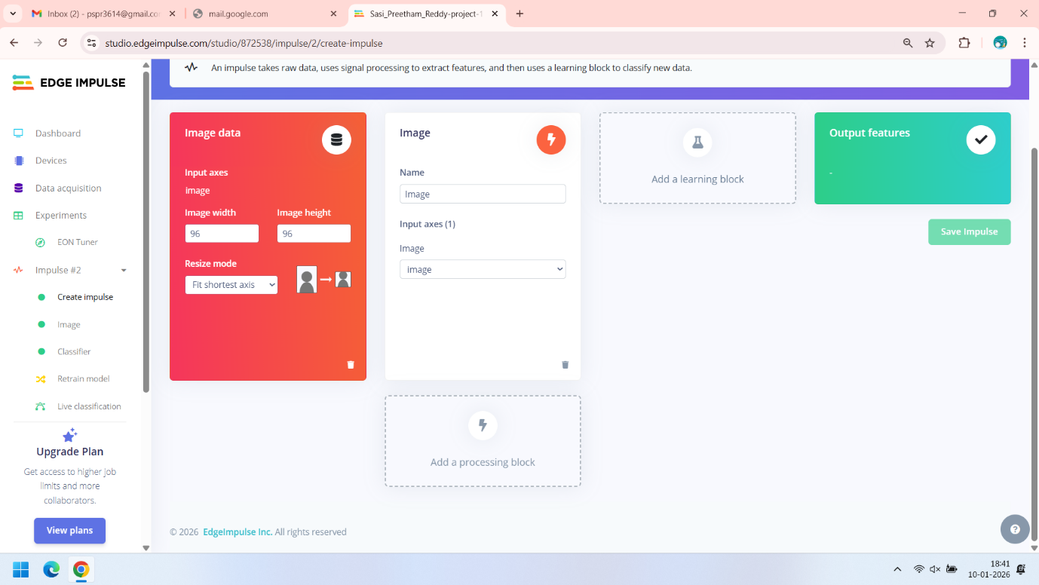  
  
Click on add learning block to select the transfer learning   
  
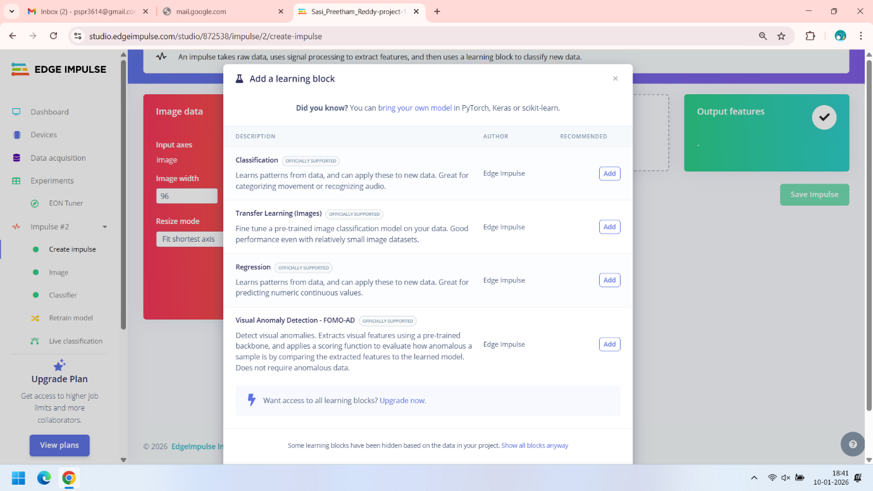  
  
Now we have added the Transfer Learning   
  
  
  
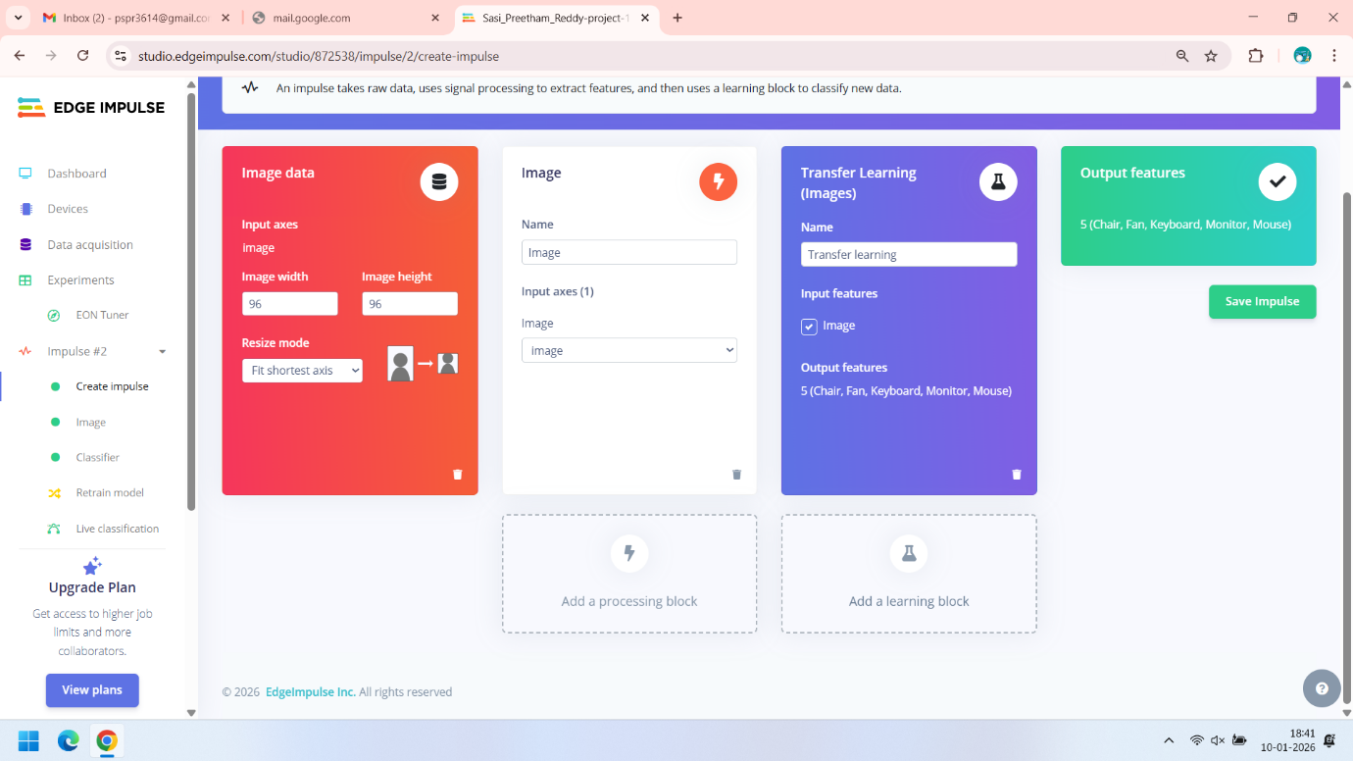  
  
Now we save the Impulse.   
After saving the Impulse we have to follow the same steps for image  
  
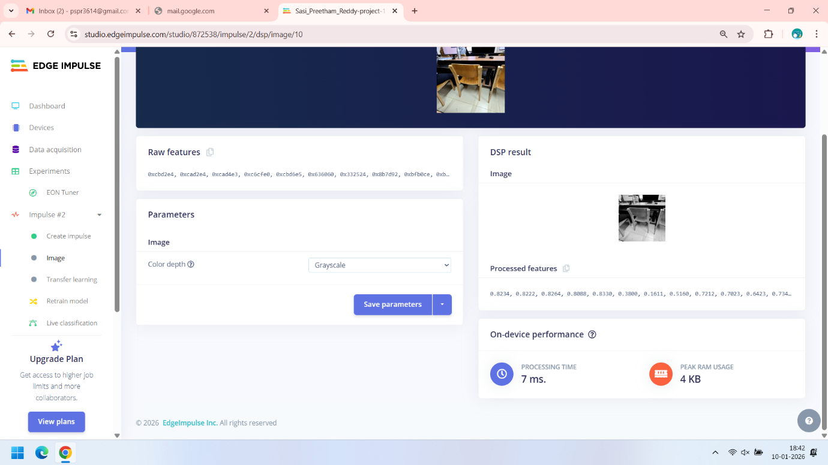  
  
Here we select for greyscale and we save the parameters.   
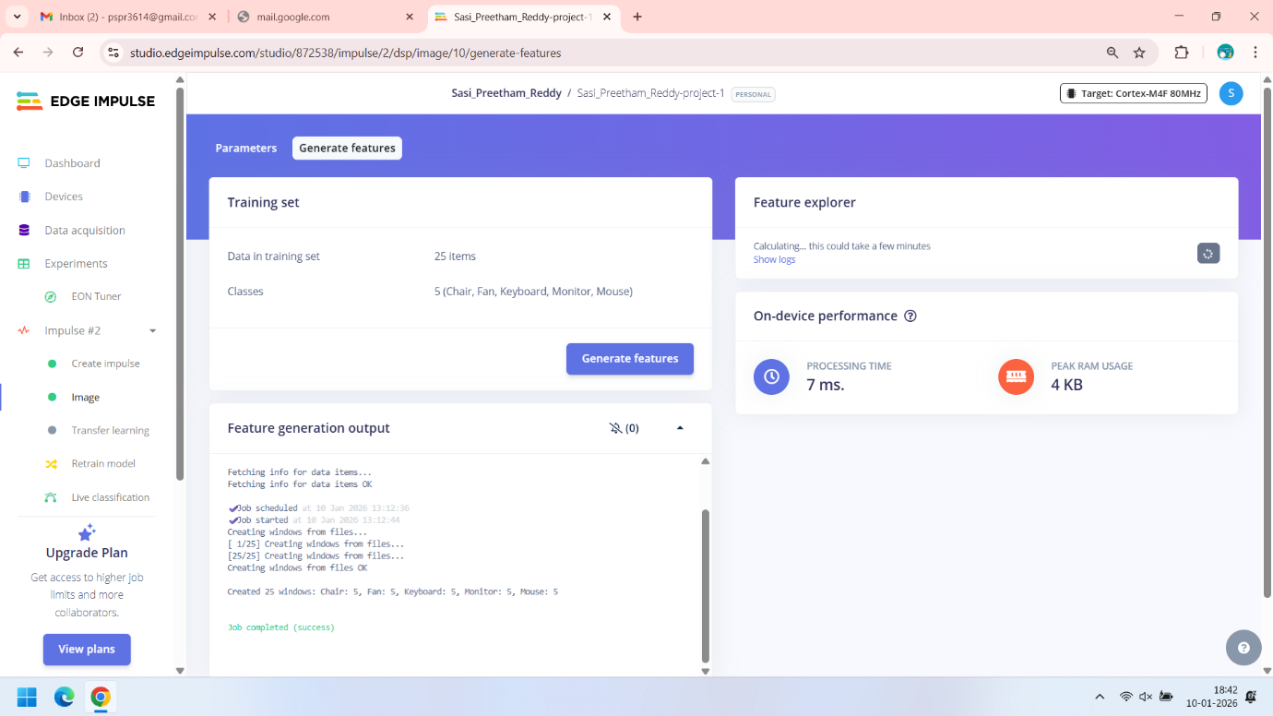  
  
Now click on generate features and after that we click on transfer learning.  
  
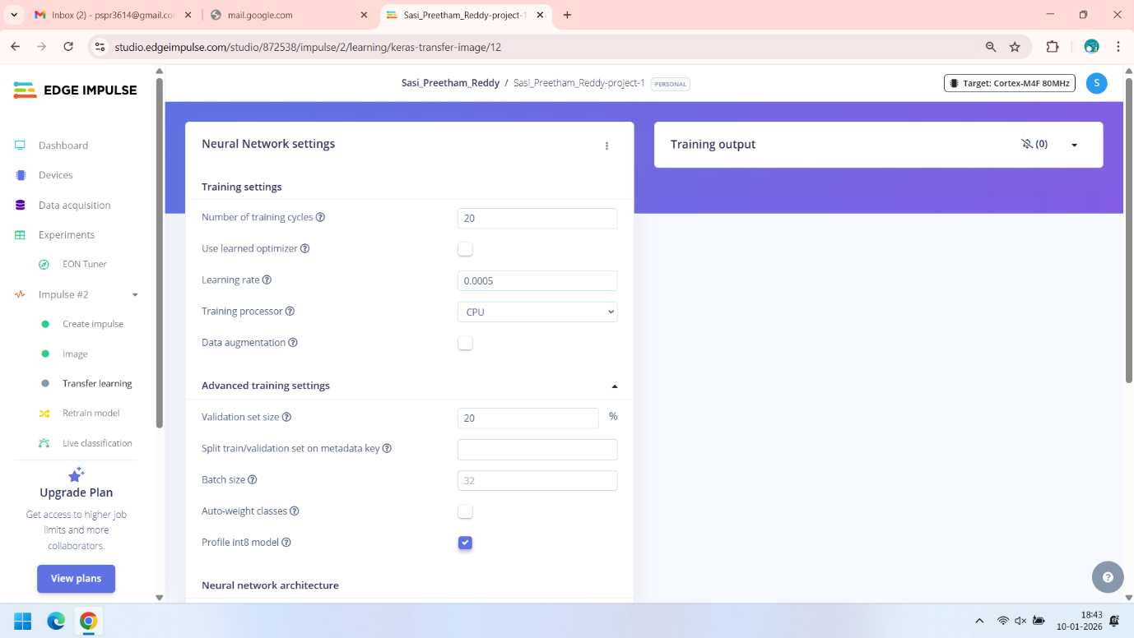   
  
These are the Models Parameter that we can change as per our wish . and By default we are using the MobileNet v2 Pretrained model. Here also we can add additional layers. Here also we have 5 output labels in the output layer.  
  
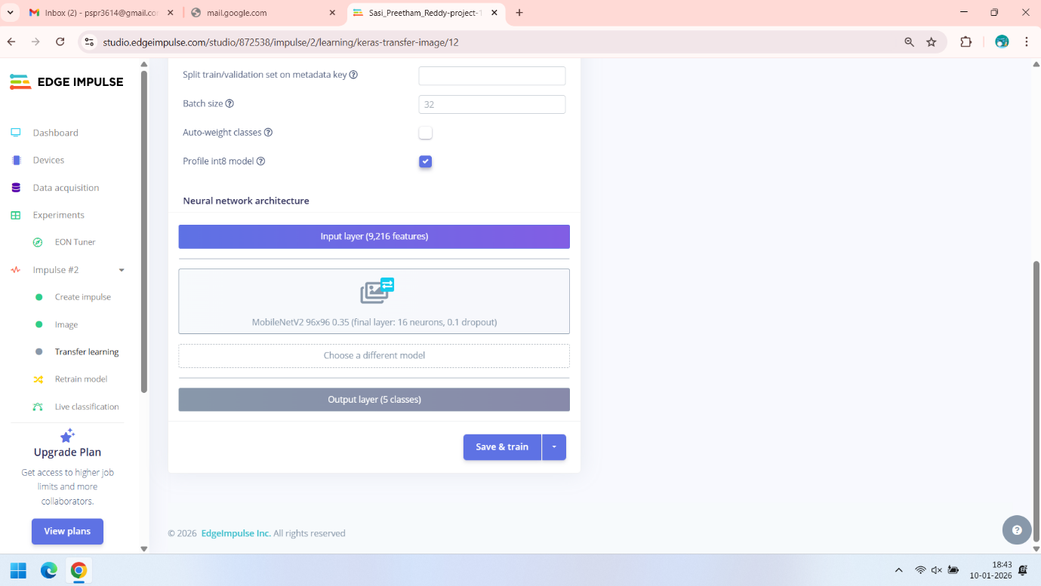  
  
we can simple click on save and train to perform transfer learning. Below are the Screen shots of the Output of the model transfer learning  
  
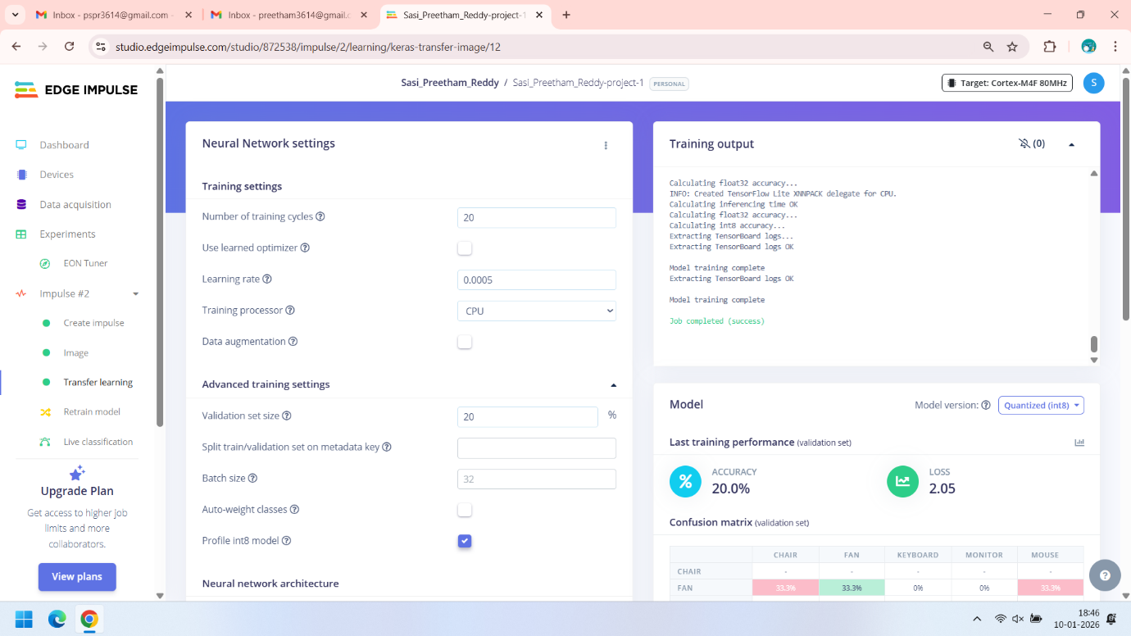  
  
  
  
  
  
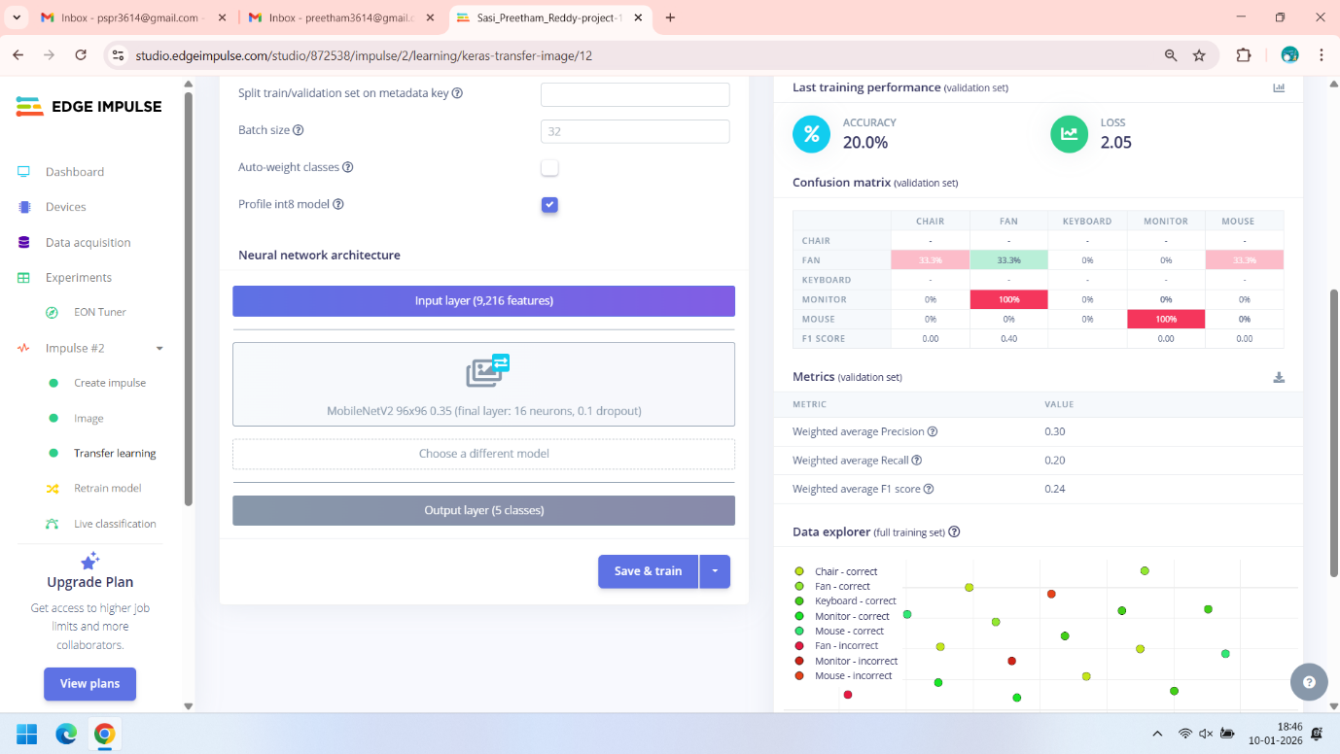  
  
So the Final Output we got is 20% accuracy with 2.05 loss. Along with accuracy we also get the Weighted Average precision , Weighted average Recall , Weighted Average F1 Score.